1. Import csv within 20sec , result with 12.35sec time taken.

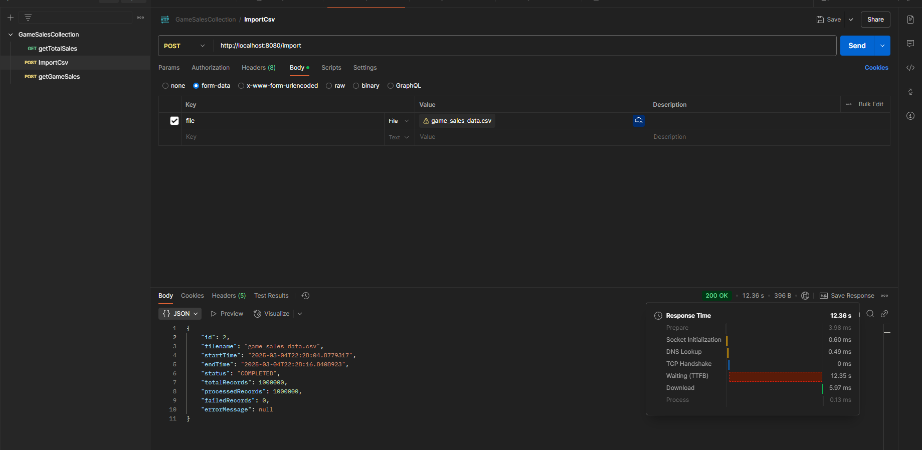  
  
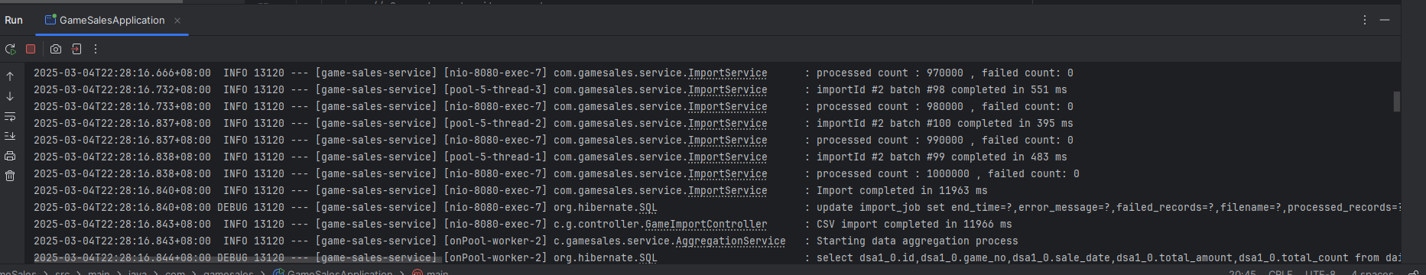

1. getTotalsales within 50ms , result as 10ms time taken

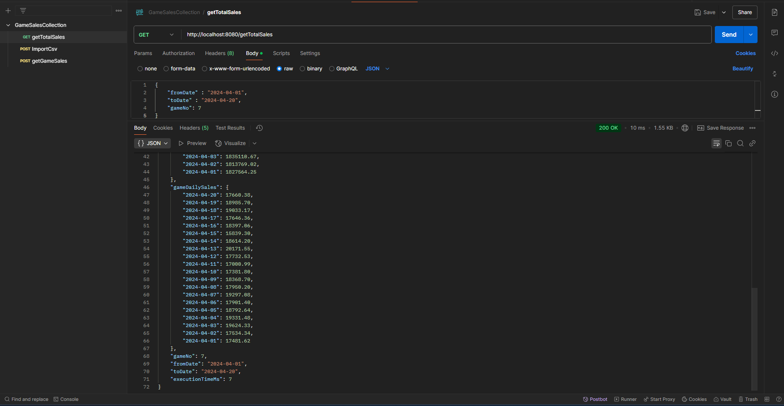

1. getGameSales within 50ms, result with 14ms time taken

